**Preliminary report on radio tracking coconut rhinoceros beetles in Guam**

Prepared by Matt Siderhurst and Aubrey Moore

**Figure 1.** Miniature radio transmitter attached to a coconut rhinoceros beetle.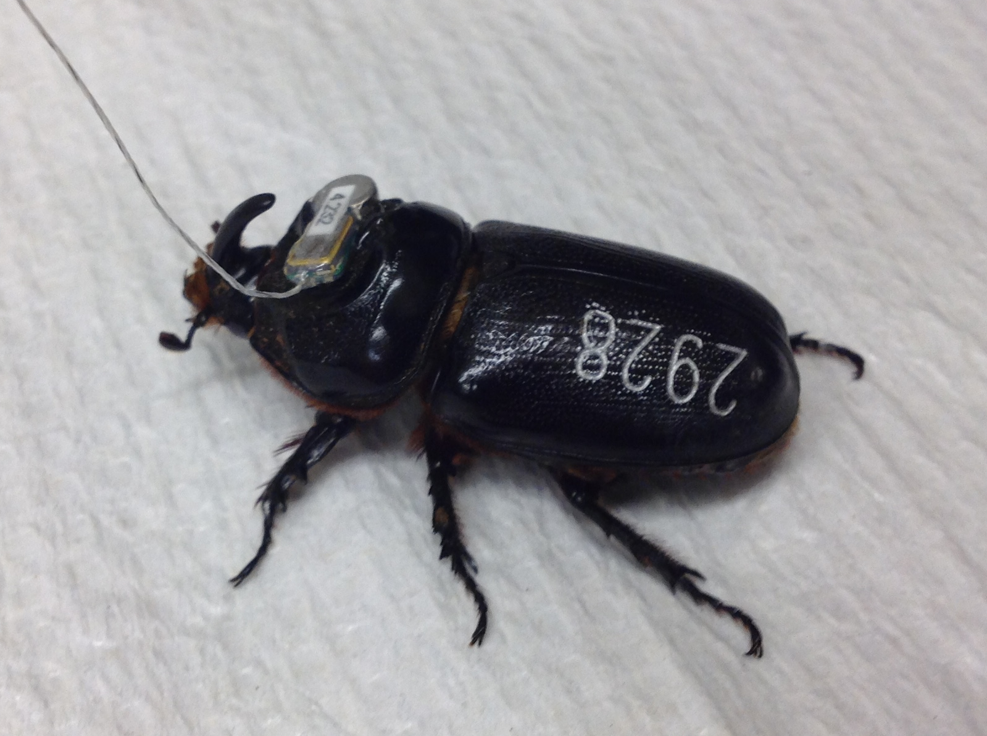

The field trial, funded by a US Forest Service grant, was performed on Guam during August 4-12, 2015 by Matt Siderhurst, Kat Lehman, Diego Barahona (Eastern Mennonite University, VA), Domenick Skabeikis (USDA-ARS-PBARC, HI), and Aubrey Moore (University of Guam, GU).

**Objective:** This pilot project was performed to evaluate the concept of using radio tagged coconut rhinoceros beetles (CRB) to detect cryptic breeding sites.

**Results:** Two locations were used in this study, each representing a different topographies and with differing vegetation cover. Approximately 20 CRB were tracked to specific locations during the course of the study. Signals from approximately 10 additional radio-tagged beetles were lost shortly after release and we believe these individuals flew beyond the range of our receivers (> 1 km).

Tracked CRB were found in a number of microhabitats including coconut trees, around CRB barrel traps, and several breeding sites. Interesting observations included:

* One CRB visited a breeding site in a recently typhoon-damaged branch 20 feet up a breadfruit tree. Three other beetles were observed in this small breeding site.
* Two CRB were observed *under* barrel traps (one of which was a breeding site). No beetles were caught in pheromone traps (40 traps at the Yigo Expt. Stn., ~10 traps at Asan Beach Park.)
* Three CRB were tracked to the same tree at Asan Beach Park.
* Four CRB were found burrowed into soil or sand.
* The majority of CRB were tracked to coconut trees (many of which were severely damaged).



**Figure 2.** The two locations used for in this study. On the left is Asan Beach Park (map is about 825 m wide), a relatively open area bordered by an elevated forest, the ocean, and swampy scrubland. On the right is a University of Guam experiment station (map is about 700 m wide), which had mixed forested and agriculture areas bordered by residential areas and more forest. *Preliminary GPS data used, not all locations have been vetted at this time.

While the line-of-sight range of the transmitters used was determined to be ~1 km, in practice most beetles were located no further than ~300 m from the release point due to interference from topography, vegetation, and power lines. Techniques related to tracking were refined including transmitter attachment and tracking protocols. Our results clearly show that tracking tagged beetles can lead to the discovery of cryptic breeding sites. Of particular interest is the fact that breeding sites were discovered in trees, sites which might prove very difficult to pinpoint using tracking dogs.

**Future study:** Technology developed in the course of this research may be quite helpful to the CRB eradication program in Hawaii as they look to identify and remove cryptic CRB breeding sites. Tracking radio-tagged beetles may also be a useful tactic for finding breeding sites as part of a rapid response to a new infestation.

The technique could be further refined by the following,

* Develop better transmitter attachment protocols (perhaps using UV cured dental adhesives)
* Further define the relationship between number of tagged CRB released and breeding sites found (“x” number of CRB are needing to detect “y” number of breeding sites)
* Develop SOP and best practices for tagging, releasing, tracking, and recovering CRB